Fresh Plaza

Rapidity of lemon increase takes South African industry by surprise
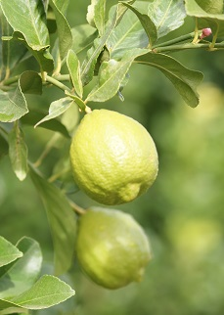By the end of week 21 South Africa had sent out 10.4 million 15kg cartons of lemons, leaving the shipments of other years in the dust: 5.3 million cartons of lemons last year this time, and many in the lemon industry have told FreshPlaza that while huge growth was totally expected, the rate at which it came this season was not.
The lemon estimate for this season stands at 27.6 million cartons.
South Africa’s largest lemon production area, the Sunday River Valley in the Eastern Cape, for instance, exported 10.2 million cartons of lemons last year – this year it’s expected to be 12 million. Packing is approaching the halfway mark in this area. Many areas have experienced close to a doubling of their lemon volumes this year.
The Senwes area, second largest lemon production area, is winding down its lemon harvest which could end above its estimate of 5.1 million cartons.
It has been a difficult season in which to experience a surge of volumes, with no demand from the juice or the food service sectors.
South Africa’s saving grace this season has been that Spain and Turkey were out early. By the end of week 21 South Africa had sent 275% more lemons to Europe and 395% more to the UK than at the same point during the previous season. There has been a 20% drop in the amount of lemons going to South East Asia, when compared to last year up to this point.
The Middle Eastern lemon market has crashed. It has received almost half of South Africa’s lemons, particularly small counts. Exporters are gritting their teeth and hoping for a stabilisation of the market over the coming weeks.
General consensus among South African lemon producers is that their lemon quality is better than that of Argentina, the other big lemon producer currently on the world stage.

Publication date: Mon 1 Jun 2020
Author: Carolize Jansen
© FreshPlaza.com

