Fresh Plaza – 8th June 2021

Now set to challenge Australia & Argentina for market share

After 12 years, first shipment of South African citrus to the Philippines
Today, a delegation from the Citrus Growers’ Association of South Africa (CGA) visited the Durban Port to see off the first South African shipment of citrus to the Philippines. This historic occasion follows twelve years of negotiations between the two countries with a landmark work plan finally being signed between the Department Agriculture, Land Reform and Rural Development (DALRRD) and the Philippines Bureau of Plant and Industry (BPI) at the end of last year.
This new market presents an export potential of 20 000 tons of citrus fruit, with export earnings of close to R205 million annually. It will also translate into more desperately needed job opportunities - at a time where Covid-19 has devastated many other industries and led to millions of job losses.
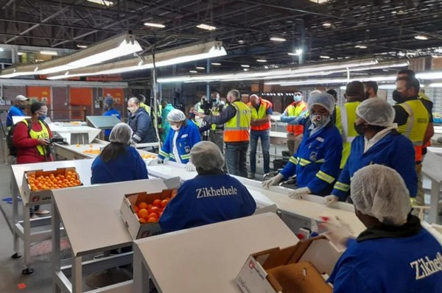
"The opening of the Philippines market also comes at a time when the South African citrus industry is expected to grow by a further 500 000 tons over the next 3 to 5 years. Expanding access to new overseas markets is crucial if we want to avoid an oversupply of the region’s exports to our existing markets," said Justin Chadwick, CEO of the CGA.
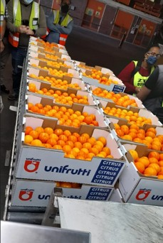
"When it comes to the current export season, the soft citrus-producing regions are expected to show the most significant growth (up 29% from last year) with mandarins expecting to grow by 42% within this category. It is therefore encouraging that this category makes up the biggest volumes of citrus imported by the Philippines, with over 80 000 tons imported between 2016 and 2018 – out of a total of 117 000 tons of citrus imported over that period.
"Up to now, Argentina and Australia have been the largest exporters of mandarins from the Southern Hemisphere to the Philippines. However, we hope that our local citrus industry will surpass these countries as the main supplier of soft citrus to the Philippines over the next few years."
Gaining access to this new market is largely the result of close collaboration between industry role players including the CGA, Citrus Research International (CRI), the South African Embassy in Manila and DALRRD.
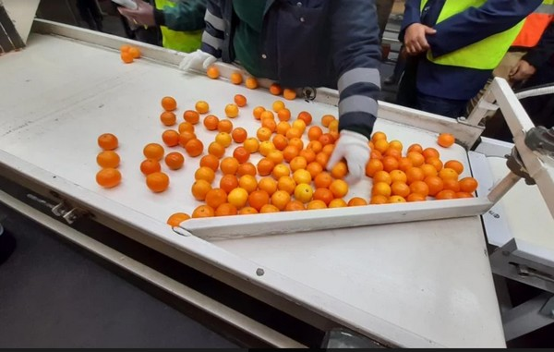
"We are pleased that the citrus industry remains well-positioned to contribute towards the country’s economic recovery. Last year, the sector enjoyed a record-breaking export season with 146 million cartons of fruit and is set to enjoy another record-breaking export season this year.
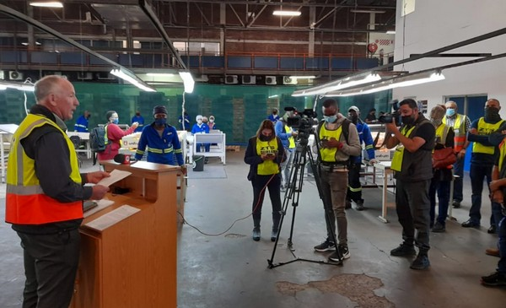
"The CGA will continue working with government to open and expand access in other key markets including China, USA, India, Japan, Vietnam and the European Union and in this way, play our part in contributing towards job creation and inclusive growth."
For more information:
CGA
Tel: +27 31 765 2514
info@cga.co.za
www.cga.co.za

