Fresh Plaza – 9th August 2021

Close to 70% of Valencia harvest is still to come

Durban port congestion obliges northern citrus growers to suspend packing for a week
South Africa’s citrus growers in Limpopo and Mpumalanga have received an advisory to stop packing fruit destined for Durban port by early evening on Friday 6 August, and only resume packing a week later.
The Citrus Growers’ Association’s directors for the Northern Regions and the board of the Fresh Produce Exporters’ Forum (FPEF) issued the advisory last Thursday as a last resort after meeting with the Perishable Products Export Control Board (PPECB) and the national department of agriculture.
“Unfortunately, no viable alternative plans were identified and consensus was reached that any additional fruit being sent to Durban would simply aggravate an already unmanageable port environment,” reads the circular sent to growers.
Some citrus packhouses already stopped packing last Thursday and all of the growers contacted by Fresh Plaza confirmed that they would heed the request.
“Overall the 2021 citrus export prediction for southern Africa is now 155 million cartons, 5% off the original estimate. The big variable in play now is the port’s ability to ship the remaining 53 million cartons,” writes the CEO of the CGA, Justin Chadwick, in the weekly newsletter.
“While the port role-players are working feverishly at dealing with the backlog, clearing containers inbound and outbound, clearing cold stores of accumulated fruit, and servicing all the fruit arriving in port, growers have been advised to ensure that their fruit can be handled before trucking the fruit to the port.”
Little margin for soft citrus programmes
Some soft citrus producers are already so far behind on their season that they risk losing fruit if they don’t continue packing. The soft citrus is approximately 70% through the estimate of 30.1 million 15kg cartons with nine million cartons left to pack.
“Those growers willing to pay to drive loads to the Cape, their pack programmes permitting, will still be harvesting. Unfortunately“ adds a packhouse manager in a soft citrus-dominant area of Limpopo, “there are few of those.”
So far, 21.1 million cartons of soft citrus have been packed and 16 million cartons have been shipped from South Africa.
Valencias: “Big numbers are to come”
Chadwick writes that South Africa has now reached the two thirds mark in terms of citrus packed and passed for export, but “the big numbers to come are in Valencia oranges – with just 30% of the predicted 55.4 million cartons already packed.”
The Valencia estimate is now 5.4% lower than the original estimate at 55.4 million cartons, close to last year’s final tally.
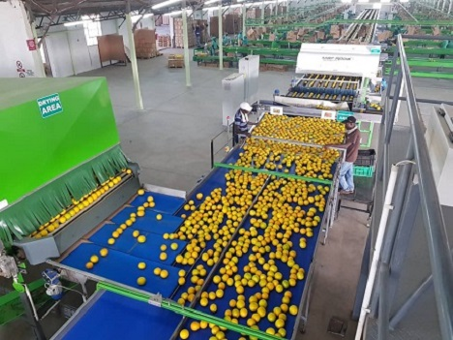
Over half of South Africa’s Valencias are grown on 17,000ha in Limpopo Province. By the end of week 30, 17.3 million 15kg cartons of Valencias had been packed of which 9 million cartons had been shipped.
The CGA/FPEF notice continues: “This measure will only work if all growers adhere to this request and allow the massive congestion in Durban to clear. With more than sixty percent of the 2021 Valencia volume still to be packed, we will need the Durban port logistics chain to operate at maximum capacity.”
The navel season is 87% done; 22.7 million cartons of navels have been shipped by the end of week 30. Grapefruit is 94% complete with just 1 million cartons of the 17.2 million predicted cartons (15Kg) to pack.
“Interestingly,” Chadwick notes, “lemons are at exactly the same point [as last year] with 94% packed and passed for export, with 1.5 million 15kg cartons still to pack to get to the latest prediction of 27 million cartons.”
Publication date: Mon 9 Aug 2021
Author: Carolize Jansen
© FreshPlaza.com

