Fresh Plaza – 19th August 2020

Chinese import volume of South African oranges shows no signs of decline in week 33
This is the time of year when many imported orange varieties enter the Chinese market. This includes oranges from South Africa, Egypt, the USA, and Australia. The South African oranges have a distinct market advantage this year because their product quality is excellent, and there is a great variety. Mr. Chen Zhiwei of Guangzhou New Origin Fresh Import and Export Trade Co., Ltd. recently talked about the current retail conditions of imported oranges from South Africa.
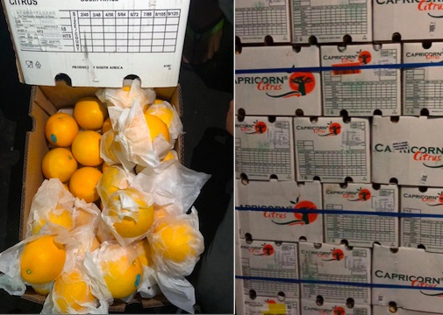
South African oranges
"At the moment, we mainly sell Valencias and Navelate oranges. The supply season of Valencias is always a bit longer, while the main supply of Navelate arrives in August. Many fruit importers and exporters suffered financial loss in the first half of this year. That was mainly because of the outbreak of Covid-19 and its impact on distribution and consumer power. The pandemic also increased the financial risks in the industry."
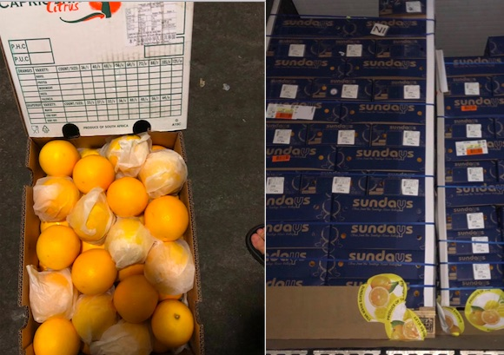
South African oranges
"Many traders have adopted a more careful and hesitant approach in the second half of this year. However, the WHO advice to eat oranges because vitamin C strengthens the immune system, has been a great stimulus for market demand. This is of course also reflected in the retail price. All in all, South African oranges are doing quite well in the Chinese market. The import volume has shown no sign of decline in week 33."
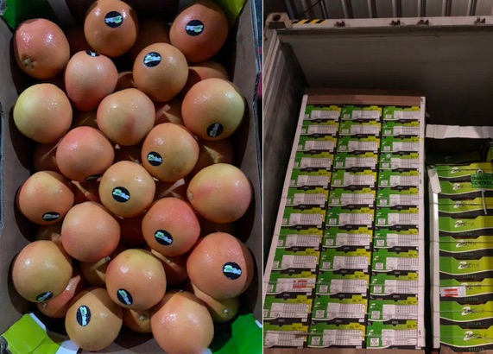
South African oranges
Guangzhou New Origin Fresh is located in the Guangzhou Baiyun Fruit Wholesale Market. The company mainly sells imported fruit through wholesale markets in Guangzhou. Their online sales volume is limited. The company offers a wide variety of South African oranges, including Zest, Limpopo, and SRCC.
For more information:
Chen Zhiwei
Guangzhou New Origin Fresh Import and Export Trade Co., Ltd.
Tel.: +86 137 2557 8725
E-mail: jefferychen@neworiginfresh.com
Publication date: Wed 19 Aug 2020
© FreshPlaza.com

