Chinese consumers show continued enthusiasm for South African grapefruit
The 2018 season for South African grapefruit has already started. The Guangzhou Jiguoxuan fruit trading company dispatched a special delegation to South Africa in April when the citrus season began. They investigated the actual conditions in the orchards and packaging factories.

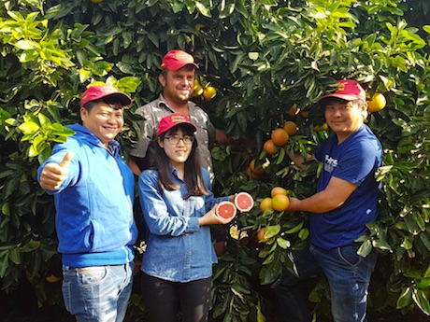
Examining South African grapefruit

The quality of citrus fruit in production areas has increased in the 2018 production season, but fruit size is smaller. This year the grapefruit matured slowly, and took a long time to get a ripe color. The official opening of the grapefruit season was therefore delayed by around two weeks. This increased the gap between the supply periods of Israeli grapefruit and South African grapefruit.

Interview with Pieter Marais, president of Jiguoxuan in South Africa

The website of Jiguoxuan states that "the interval between supply from these two production areas is greater this year, which means that traders who are desperate to sell their late-season Israeli grapefruit can still sell them at a good price, despite the relatively poor quality of late-season Israeli grapefruit."

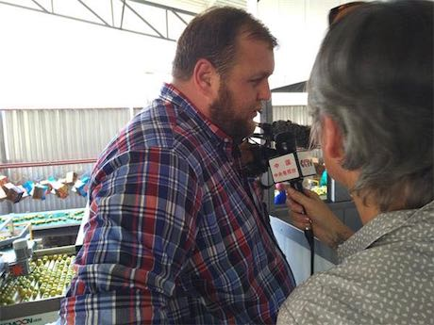
Interview with Pierneef Smit, vice-president of Lvmeng in South Africa

There are farmers who see the opportunity here and harvest grapefruit early for export to the Chinese market, even though it increases the cost price. The first shipping containers of this season arrived on wholesale markets in Guangzhou and Jiangnan. The price of South African grapefruit from this shipment can be as high as 390 yuan [61.16 USD] per box.

Interview with Li Zhixue, sales manager of Guangzhou Jiguoxuan

Jiguoxuan gave an interview to Gill of CCTV in Johannesburg on April 25th, 2018. This interview revolved around South African production and harvest, and Chinese market demands. These will also be specialist topics during the summit meeting in Capetown in August when the five BRICS-countries meet. During the interview they discussed new types of cooperation, e-commerce platforms, and the popularity of South African grapefruit.

Jiguoxuan is a company that has more than 20 years of specialized experience in fresh produce import from South Africa. Not only do they continue to collect and select high-quality fruit from suppliers in South Africa, they also maintain a strong, optimal retail marketing structure in China--wholesale markets and e-commerce platforms. CCTV assists in a production that gives publicity to the BRICS Summit Meeting and showcases the development of agricultural cooperation between China and South Africa.

Fresh Plaza
Publication date: 5/16/2018

