Fresh Plaza:

South Africa: Port of Cape Town restores berthing teams after staff shortages
According to a Transnet statement, Cape Town Container Terminal (CTCT) has pushed its operational staff complement of “gangs” working vessels at the port to five. This comes after Covid-19 infection fears significantly eroded the number of personnel required to sustain port efficiency.
With an increasing number of staff returning from self-isolation to attend to their various berth responsibilities, port officials last week tried to restore operational efficiencies to at least four gangs every day – a basic requirement for optimum port function.
The statement says: “Within the human capital constraints presented under the pandemic, the CTCT is operating at just below 60% and the Multi-Purpose Terminal (MPT) at 75%. The strategy is to increase and activate additional resources in the short term. This is being achieved through the reintegration of employees returning from quarantine, as well as those who have recovered from the disease.”
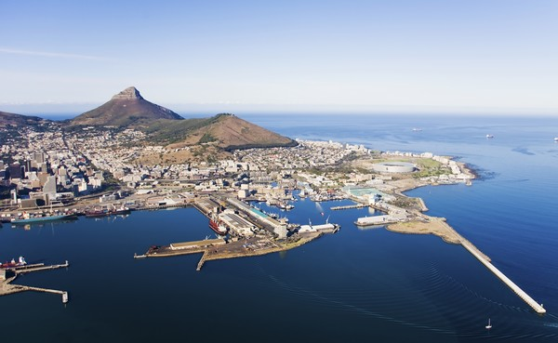
With regard to staff over 60 and those with chronic conditions, Transnet added it was relying on “medical reviews” to have both the benefit of these personnel reporting to work yet erring on the side of caution insofar as health, hygiene and curbing contagion were concerned.
Applicable parts from the rest of the statement read as follows: “The CTCT has already commenced implementing a fifth gang on the waterside, which will greatly assist in reducing vessel berth time. However, it needs to be borne in mind at this time that the pandemic is still to reach its peak
Source: freightnews.co.za
Publication date: Fri 26 Jun 2020

