Fresh Plaza – 11th June 2019

Arrival of first shipment of citrus in breakbulk vessel into China
The Baltic Summer reefer vessel carrying citrus from South Africa to the People’s Republic of China had arrived at Shanghai Port on 10 June 2019. The historic shipment of 5200 tons of citrus in a breakbulk vessel was launched on 6 May 2019 at Maydon Wharf Port in Durban. The reefer vessel was cleared upon arrival without any sanitary and phytosanitary challenges.
The South African Consul General, Mpho Hlahla and DAFF attaché to the People’s Republic of China, Mr Mashudu Silimela were present to welcome and receive the vessel. Mashudu and the team in Plant Health and Inspection Services Directorates played a significant role in the negotiations for the use of breakbulk vessels instead of containers.
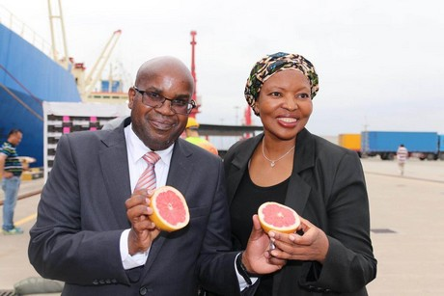
The Minister of Agriculture, Land Reform and Rural Development, Thoko Didiza, congratulated the department for the successful negotiations which resulted in the approval of Break Bulk vessel shipment and thanked all the parties and the industry who were involved throughout the process since its inception in 2006.
This signals growth to the South African citrus industry in South Africa and will result in creation of more jobs. The use of break bulk vessel at the port will clear the congestion at the port due to some challenges currently experienced.
For more information:
Zweli Silangwe
Tel: +27 76 925 9875
E-mail: ZweliS@daff.gov.za

