Fresh Plaza

International body appoints new president
Anton Kruger is the South African Fresh Produce Exporters’ Forum’s (FPEF) CEO. He has now also been appointed as president of the Southern Hemisphere Association of Fresh Fruit Exporters (SHAFFE).
Kruger’s appointment was officially endorsed on 14 May at a virtual meeting. This was done by the SHAFFE secretary and all its member countries. SHAFFE’s former president, Dr. Konanani Liphadzi, resigned as Fruit South Africa’s CEO. That was at the end of March and Kruger was, therefore, appointed. He will remain the SHAFFE president until 2021. Then a Chilean representative will be elected to the post.
SHAFFE is currently involved in global campaigns. These are aimed at promoting awareness and use of fresh fruit among consumers. SHAFFE is fulfilling an additional role during the coronavirus outbreak. They are gathering information from member countries. This includes data about logistical and administrative issues. These problems lead to the accumulation of fruit in fruit-importing countries’ ports.
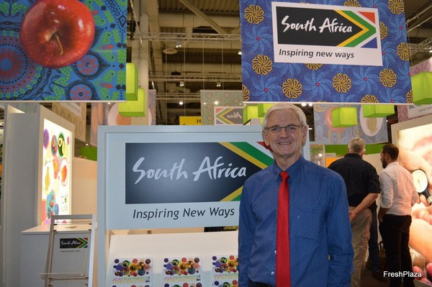
Essential service
During the virtual meeting, Kruger said it was remarkable to hear that fresh fruit exports were declared an essential service. That was the case in all member countries at the start of the respective countries’ lockdowns.
SHAFFE usually focuses on mutual concerns. These not only include the use of plastic in the fresh fruit export sector. Sustainability, ethical practices, the environment, and energy use are also included. “Some of these issues still deserve attention, even during this COVID-19 time. That is needed to ensure there are no sudden ‘surprises’ for members. These could hamper exports and market access.” Kruger says.
For more information:
Anton Kruger
FPEF
Tel: +27 21 526 0474
Email: anton@fpef.co.za
www.fpef.co.za

Publication date: Fri 29 May 2020

