Fresh Plaza: 23 August 2018

South Africa: Agri SA welcomes ANC’s commitments on agriculture
Agri SA is encouraged by a productive discussion with senior ANC officials regarding agrarian reform and agricultural property. It is highly appreciated that specific policy commitments were made, among others:
- No land grabs will be allowed.
- The protection of productive agricultural land will remain a priority.
- Optimising the use of fallow land in deep rural areas.
- Property rights will remain a key priority in agrarian development.
- Government is finalising an audit of state land for transfer to black farmers
- Initiating production on 4 000 farms currently in government possession to unlock commercial value and create farming opportunities.
Agri SA and Agbiz met with David Mabuza, ANC Deputy President, and Paul Mashatile, ANC Treasurer General. This is in addition to the meeting between President Cyril Ramaphosa and Agri SA President Dan Kriek, to be held in Cape Town today.

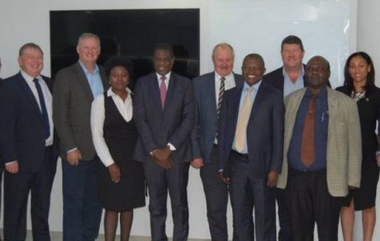

“Agriculture is asking for a collaborative framework for growth, similar to what the motor industry has achieved,” said Francois Strydom, Agbiz Chairman. “All the players in agriculture are keen to take this process forward.”
The Inter-Ministerial Task Team on Land Reform was also discussed at the meeting; an invitation was extended to organised agriculture to delegate three representatives.
“This historic meeting sets a foundation for a lasting partnership with the aim to sustainably transform and grow agriculture,” said Omri van Zyl, Agri SA Executive Director. “However, our focus will remain on negotiating for tangible benefits for producers.”
Source: agrisa.co.za

