Fresh Plaza – 8th September 2021

Pick n Pay shows love through its mandarins
South African retailer Pick n Pay is again using its premium mandarin line as a canvas for its social commitment: for the month of September, the mandarin boxes will be Springbok green – the colour of the jersey of the national rugby team – as South Africa meets the All Blacks, the New Zealand rugby squad, later this month for the one hundredth time and exactly a century since they first met.
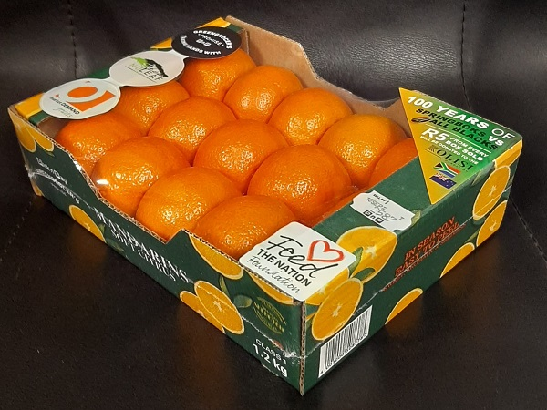Pick n Pay celebrates a hundred years and a hundred matches played between the Springboks and the All Blacks (photos supplied by Pick n Pay)
“It’s once again thanks to our incredible suppliers, Nu Leaf Brands and Market Demand Fruits, as well as the ‘Feed the Nation Foundation’ that we can present our Green Mandarin Box,” says Rebecca Fifield Cooper-Williams, food technologist at Pick n Pay. “For the month of September, for every green box sold, R5 will be donated to the Kolisi Foundation.”
She notes that the gold of the late mandarins on the green box and the green-and-gold of the Springboks is “serendipitous”.
Initiatives addressing food insecurity
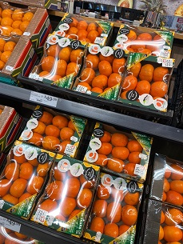The Kolisi Foundation was set up last year by Springbok captain Siya Kolisi and his wife Rachel in response to the profound inequality in South Africa.
Food security is one of the organisation's focal points, addressed through the ‘Each 1 Feed 1’ campaign’ launched last year. This campaign, in collaboration with the Nelson Mandela Foundation, was designed to support food-insecure households for a minimum of three months.
In what started as an emergency relief fund in response to the Covid 19 pandemic, the Feed the Nation Foundation has provided more than 33 million meals to the value of R150 million (8.8 million euros) to vulnerable communities around the country, which includes thousands of learners from child-headed households.
Excellent quality on Western Cape mandarins
“All of the late mandarins currently being used for this campaign are from the Western Cape. Sizing is slightly smaller than previous years, but quality is excellent. The skins are deep orange in colour and the fruit very sweet and flavourful with balanced acids,” says Paolo Pera, senior citrus procurement specialist at Nu Leaf Brands.
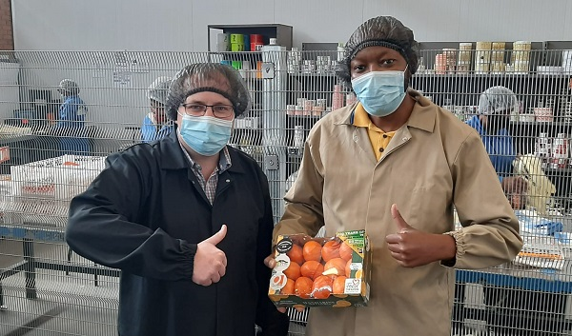
Paolo Pera, senior citrus procurement specialist at Nu Leaf Brands, and Jordan Sibiya, Pick n Pay food technologist, with the green-and-gold box

Publication date: Wed 8 Sep 2021
Author: Carolize Jansen
© FreshPlaza.com

