Fresh Plaza – 6th June 2018

Week-long Sundays River citrus strike intensifies with arson attack
Just when Sundays River Valley citrus growers thought they’d recovered from last year's disastrous navel season, their navels suffer another setback. There is no end in sight to the current strike, already running for a week, while the incidence of navel creasing is on the rise as navels which should’ve been harvested by now, remain on the trees.

Fears of a repeat of the arson attack on a citrus packhouse in the Eastern Cape Midlands (more than 200km to the northeast) a month ago, were realised last night when a tractor shed on a Kirkwood farm was burned down, along with a neighbouring orchard and packing bins.

At the large packhouses extra armed security personnel were brought in at the beginning of the week and a public order policing unit of the South African Police Service was deployed. Today police helicopters can be seen circling the towns of Addo and Kirkwood.

The Eastern Cape MEC for Rural Development and Agrarian Reform, Mlibo Qoboshiyane, and the South African Communist Party provincial secretary Xolile Nqatha are meeting farm workers in the area this afternoon. Furthermore, in the light of the intensification of violence, an application for an interdict preventing certain South African National Civic Organisation (SANCO) members from approaching citrus packing facilities and farms will be heard by the Port Elizabeth High Court today.

In Kirkwood the municipal offices as well as many businesses are closed today.

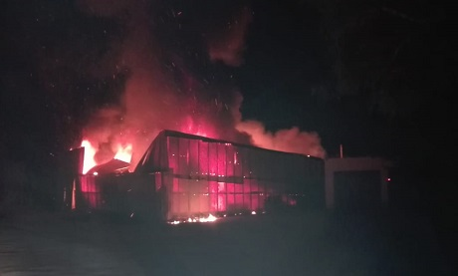
A tractor shed goes up in flames on a Kirkwood citrus farm last night (Source: Facebook)

Losses to this production area could run to around R17 million (1.15 million euros), the South African Broadcasting Corporation reports.

At packhouses thousands of bins are standing out in the sun, some containing fruit that should’ve been out to sea by now, others that never even made it to the degreening chambers. Inside packhouses that had to be evacuated in a hurry fruit are still on the line.

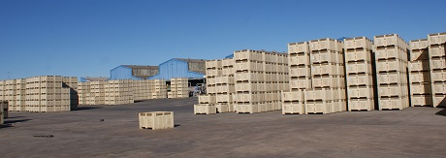
Bins full of navels, already standing for six days out in the sun at a Sundays River Valley packhouse

“The degreening cycle is normally six days, so navels are normally around six days old by the time you pack it and now you’ve added another six days on to that, so by now the fruit is twelve or thirteen days old,” explains a packhouse manager, adding that the degreening process already reduces shelf life. “When we start packing again we’ll have an emergency meeting to decide on the fate of the fruit that has been left in limbo by this strike. It all depends on how long this will go on.”

He points out that with navel volumes almost 40% down last year and consequently fewer shifts, packhouse staff already had a diminished income. "They were actually telling us that they were hoping for a normal season this year."

On farms bins with fruit that never made it to the packhouse are standing around. Novas and navels were being harvested, some lemons, ironically a navel season with “fantastic” internal quality, generally better sizing than the earlier navels from the Senwes area up north as well as false codling moth at possibly the lowest level ever.

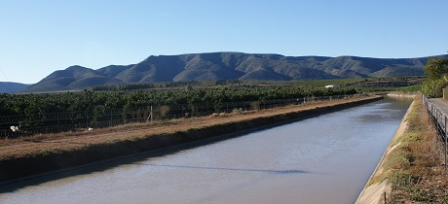

Work had already stopped in Addo packhouses by last Wednesday morning and in Kirkwood, about 30km northwest, work came to a halt that evening.

A week on and most packhouses are still not operating, although here and there some packhouses tried to do emergency packing yesterday with staff that didn’t need to come to work from any of the predominantly black neighbourhoods, but in today's heightened atmosphere all activities have ceased.

Wage talks have broken down

Negotiations between the Sundays River Producer Forum and protesters, represented by the South African National Civic Organisation (SANCO), have broken down for the moment. The Sundays River Producers Forum does not recognise SANCO, which is not a trade union, as representing the mostly un-unionised labour force.

The demand is for a wage of R20 (1.36 euros) an hour, the new national minimum wage for workers in most sectors of the economy, but not farm workers, whose wage has been set at R18 (1.22 euros) an hour, from 1 August 2018.

The Sundays River Producer Forum, not being a statutory body, cannot oblige its members to follow a prescribed salary structure, but it has recommended that its members already adopt the new national minimum wage of R18. Industry insiders point out that many workers are already earning more than that, and many are even earning more than the demanded R20 (1.36 euros) an hour.

Social responsibility is a necessity to citrus companies, who deny claims of negligence or brutality towards farm workers. "If you look after your workers, they'll look after you, and we've put in a lot of effort to look after our workers," says a representative of one of the major citrus companies in the area.

Harvesting and packing activities in the Eastern Cape’s Gamtoos Valley as well as in the Midlands, both more isolated locations than the Sundays River Valley, are continuing as normal.

Publication date: 6/6/2018
Author: Carolize Jansen
Copyright: www.freshplaza.com

