Fresh Plaza – 25th April 2018

Planning sessions for a positive 2018 South African citrus season
Summer Citrus from South Africa (SCSA) is proud to announce the start of what it says is a prosperous season despite the challenges associated with the droughts occurring in the Western Cape. The company says that with international best practices, innovation and the latest technology, growers are able to maximize their resources in these difficult times to produce an increased volume of good looking crop.

Easy Peelers, followed by Navels and Star Rubies, will start to arrive in containers in the United States towards the end of May, with the first conventional vessel arriving the third week of June at the port of Philadelphia. To support a successful 2018 season, members from across the U.S. and Western & Northern Cape came together in March for the Annual Planning Meeting, hosted by SCSA, to review sales and marketing plans, production volumes, shipping schedules, and category trends.

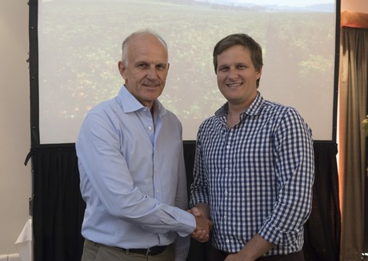
Johan Mouton (left), and Boet Mouton (right)

“The annual planning sessions form a critical part of our forward planning as this is the time when importers, retailers and growers have the opportunity to exchange information regarding current production and market conditions,” said Suhanra Conradie, CEO of Summer Citrus from South Africa. “Despite the severe drought in the Western Cape, the group estimates to increase volumes to the United States.”

Among one of the most noteworthy parts of the meeting was the announcement by vice chairman of the board of directors Gert Kotze of Johan Mouton stepping down as chairman of the board and introduced Boet Mouton as incoming chairman – a generational change in leadership that the brand is very excited about as it continues to be “young enough to change, but old enough to know better” as explained by Conradie.

“I’m honored to have the opportunity to follow in the footsteps of previous chairmen leadership by bringing new ideas and opportunities to the board of directors this season,” said Boet Mouton, chairman of the board for Summer Citrus from South Africa. “We have a lot of great work ahead of us and I look forward to renewal whilst building on the foundation that has been laid.”

Suhanra Conradie (left), and Karen Caplan (right)

Other presenters at the Annual Planning Meeting included DMA Solutions, Inc. CEO Dan’l Mackey Almy and vice president Megan Zweig, who presented the brand’s marketing results from last year’s season, as well as the 2018 marketing plan, including a Sweet Summer Sweepstakes to encourage all ages to enjoy Summer Citrus from South Africa with their favorite summer activities. Karen Caplan, President and CEO of Frieda’s, also led as keynote speaker about the importance of retail partnerships, innovation, and opportunities for the brand to grow in the US market.

“It was exciting to learn from this group of top citrus growers the innovations they have planned for upcoming seasons,” said Karen Caplan, President and CEO of Frieda’s Specialty Produce. “I also encourage retailers to travel to South Africa so they can experience their passion and high quality in person.”

New this season, the brand is sending a bi-weekly trade newsletter to include crop updates, availability, promotional efforts, and grower spotlights to ensure the U.S. is updated on opportunities for the 2018 SCSA season.

For more information:
Beth Keeton
Tel: +1 (214) 444-7459
bkeeton@dma-solutions.com
www.summercitrus.com

Publication date: 4/25/2018

