Fresh Plaza – 19th August 2021

Pick n Pay launches locally grown blood oranges, a first for SA retail

South African retailer's citrus display wows customers
This Women’s Month, Pick n Pay has teamed up with fresh produce suppliers, Nu Leaf Brands and Market Demand Fruits, and turned their usually black premium citrus cartons pink to demonstrate the retailer’s longstanding commitment to women’s rights.
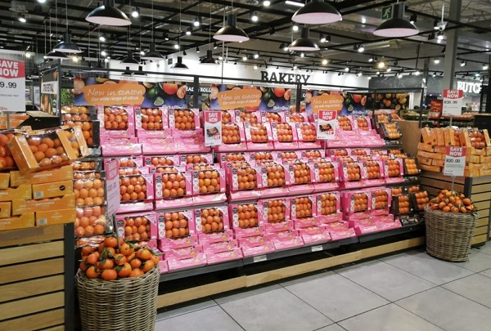
Pick n Pay introduced pink boxes for their premium citrus in support of Women's Month (photos supplied by Pick n Pay)
Pick n Pay Constantia, Cape Town, an unrivalled citrus display was set up in time for Women’s Day on 9 August, and similar displays were mounted at Pick n Pay stores across the country where the pink mandarin box is available.
Of the sales price, R5 is donated to the Cancer Association of South Africa (CANSA) on every box.
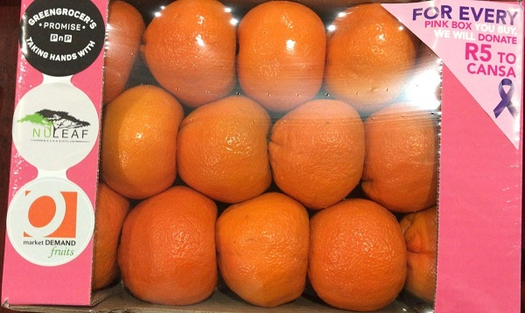
Innovative display
Pick n Pay’s fresh produce division trialled mandarins, with their leaves still attached after being picked, in the display, a decision met by an overwhelming response, says Rebecca Fifield Cooper-Williams, Pick n Pay food technologist.
“So many stores have phoned asking for more and more fruit with leaves to be sent in. The fruit gets specially picked with leaves still attached and it makes the displays in store just look so fresh and enticing.”
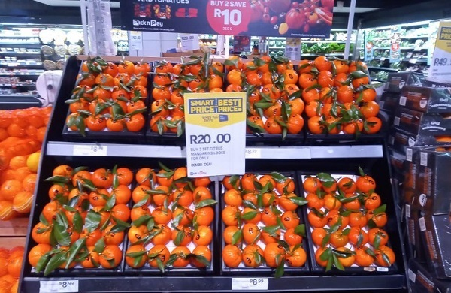
The use of waxed citrus foliage in the display creates a fresh look that appeals to customers
This season Pick n Pay customers are enjoying their citrus, as well as other fruits and vegetables, as much as during the peak of the Covid-19 pandemic last year.
“We have definitely seen a rise in demand on many fruits during this period, as well as vegetables linked to boosting the immune system, like ginger and garlic,” Liz van Niekerk, head of produce and horticulture at Pick n Pay remarks.
Blood oranges
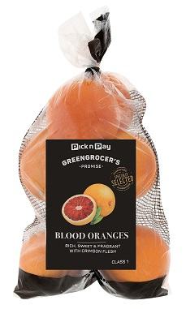
The retailer launched locally grown blood oranges this month in their stores.
“This is a first for retailers in South Africa and has been quite the learning curve to get the internal colour to where we want it,” Rebecca says.
“The blood oranges have a deliciously sweet and distinctive flavour along with the crimson-coloured flesh. In addition to the health benefits of citrus fruits, the blood oranges are full of anti-oxidants called anthocyanins that give them their colour.”
She continues: "It is thanks to working with our incredibly energetic and innovative suppliers, Nu Leaf and Market Demand Fruits, that we manage to bring these developments to our customers."
“We are continually reviewing the use of plastic and packaging options. We have an exciting organics launch coming up this summer, where we have spent a lot of time researching the packaging types, in terms of composting ability and recyclability,” says Liz.
Publication date: Thu 19 Aug 2021
Author: Carolize Jansen
© FreshPlaza.com

