Fresh Plaza – 15th May

Excellent soft citrus & navel crops amid a slew of uncertainty – Sundays River, E Cape
At the Sundays River Citrus Company, apart from their mainstay of lemons, they’ve started packing navels and Novas, crops formed under the most favourable growing conditions the district has had in years – good rain, less wind, amicable industrial relations – plus export demand for soft citrus and navels is very strong.
If it weren’t for the giant unknowns of the season, this might have been a tremendous citrus campaign, but as it is, says Hannes de Waal, managing director of the Sundays River Citrus Company, the only position to take is one of optimistic uncertainty.
"The model that predicts consumer behaviour now doesn't exist"
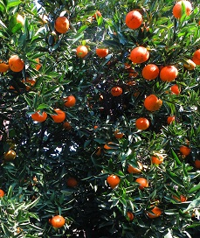“You know you have a product that the consumer wants, and we’re very happy with the sizes and the quality we’re seeing, but when this pandemic is over there are many people in the West who won’t have an income anymore."
"For the first time since the world wars people have been told to go back to their homes, and the model that predicts consumer behaviour from here on, doesn’t yet exist.”
What one can see, he notes, is that people are spending their money on two things: food and home entertainment.
The South African lemon season started earlier and at a heady pace, filling the gap left by Spain’s lighter crop.
"What are SA and Argentina going to do with their big lemon volumes?"
“The big question is what South Africa and Argentina are going to do with their large volumes. The juice and oil markets are not strong but the fresh markets aren’t bad. If consumption continues as it is at the moment, it could be a very good season. If consumption drops, we could have a problem, but at the moment there’s no indication of a drop in consumption.“
In Europe it seems like lemon consumption is normal, perhaps a bit stronger than usual, but the industry is so fragmented, he says, there’s an absence of good market reports and they’re worried about a possible change in consumption patterns.
“In the Middle East lemon demand wasn’t very strong, just as we expected, because of the huge amount of early South African lemons from the north of the country, particularly small counts, sent to the Saudi Arabia and Iraq and Dubai, but the market has been absorbing the fruit. Middle Eastern lemon shipments are decreasing, which should stabilise the market.
China emerges as a lemon exporter
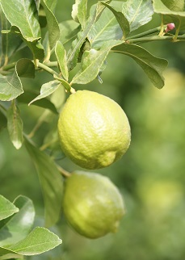South East Asia has been rather disappointing, he says, adding that it’s been difficult to find out exactly what market conditions are, but it’s slowly changing back to the way things were as countries start emerging from the shadow of the pandemic.
Another unknown is China’s growth as a lemon exporter to destinations like the Middle East and the Ukraine.
He continues that Russia was tremendously high a while back, but it has been normalising.
"The economies of oil-producing countries is another worry.”
There is a preference for citrus at this stage, but whether it’s a trend and how it long it will continue, is impossible to predict.
Citrus sales might fare better this Northern summer holiday
“The whole world is different. Will the familiar Northern Hemisphere holiday pattern kick off in as usual? I wonder about that,“ Hannes says. “And maybe citrus sales won’t drop like it has always dropped that time of the year. However,“ he adds, “ restaurant owners tell me they expect that the restaurant sector will only return to normality in at least two years’ time. I think people will prefer eating at home for a while still to come, and citrus consumption will stay high, which is good for us.”
“We’re taking it day by day but the level of uncertainty is enormous. You’re sitting with an immensely complex set of variables. Suddenly all of the rules have changed. Lockdown regulations are costing us an arm and a leg. We’re not skimping on a cent to keep our people safe and we’re putting all sort of extra precautions. We’re keeping our heads down, doing what we can, and if all of our people can still be working next year, and all of our farmers are still here, then we’ve succeeded.”
Hannes notes that the disease is on the rise in the nearby cities of Port Elizabeth and East London and there has been one confirmed case in the Sundays River Valley.
For more information:
Hannes de Waal
Sundays River Citrus Company
Tel: +27 42 233 0320
Email: srcc@srcc.co.za
https://www.srcc.co.za/
Publication date: Fri 15 May 2020
Author: Carolize Jansen
© FreshPlaza.com

