Difficult run-up to Chinese Mid-Autumn Festival for South African citrus suppliers
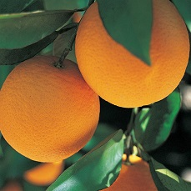The Chinese Mid-Autumn Festival falls on 21 September this year, two weeks earlier than last year’s festival, which further narrows the window for South African exporters.
“We’re sending about 50% of our planned volumes as a result of the problems at the harbour. These are precisely our peak weeks, from week 30 to week 34, to get fruit into China for the Moon Festival in September,” says a buyer for Chinese wholesale.
“At this stage, year-to-date from the start of the citrus season, we’re down by half on our exported volumes. We should be making up the shortfall now but it’s just not possible.”
It’s been a double whammy for South African exporters already used to the annual citrus peak port congestion: first the unprecedented looting and civil unrest, closely followed by a cyber attack on Transnet Port Terminals’ Navis software system. Moreover, there are significant delays on the Chinese side from arrival to being cleared by customs, traders report.
Container shortages appear to be less acute than at the end of the grape season six months ago, some say, while others maintain that there still is a shortage of equipment.
Stable orange market, but heavy pressure on Novas
Another challenge presented to Chinese exports is fruit sizing which is smaller this year, reducing the proportion of the crop available for China.
The Chinese citrus market is looking promising on oranges. Volumes on the market are slightly lower this year and recently, orange prices have increased.
“Soft citrus and especially Nova prices are under tremendous pressure and it’s difficult to move stock given the volumes of mandarins in the market."
Port operations improve
At the Durban container terminal loading has increased and exporters report an improvement in the flow of fruit after the cyber-attack.
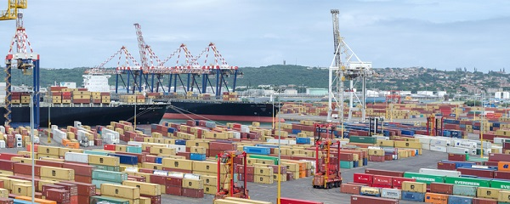Durban Container Terminal (photo: Druid007 | Dreamstime.com)
Transnet Port Terminals earlier this week told customers: “For the Durban Container Terminals (Pier 1 and Pier 2), where the import volume pressure was most evident, the daily volumes reflect a terminal system which has pushed hard to evacuate and recover.”
From 2 to 9 August a record-breaking number of containers were evacuated from Pier 2, as a result of a focused mass evacuation model, the company said.
Heavy wind, ranging and fog have periodically brought the terminals at Durban, Cape Town, Port Elizabeth and Ngqura to a standstill at various points over the past week.
Publication date: Fri 13 Aug 2021
Author: Carolize Jansen
© FreshPlaza.com

