Fresh Plaza - 13th June 2019

Welcome respite from negativity in the orange sector in Europe

China exerts a strong and early pull on South African navels
An Eastern Cape citrus exporter is sending more navels to China than ever before: the market is a welcome counterpoint to Europe.
“Our quality allows us to send more to China where there’s a definite opportunity for South African fruit, albeit within the limitations of cold treatment capacity to send there,“ says Snyman Kritzinger, marketing manager of Grown4U in Kirkwood.
“The need for fruit in China is higher than normal for this time of the season. Spain and Egypt have basically finished sending there, Australian fruit is too expensive (50 to 60% more expensive than South African fruit because of their labour costs) and with the Trump-China trade issue, Chinese buyers aren’t taking American fruit.”
Early navels this year firm enough for China
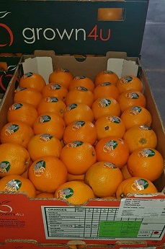Traditionally, they send Late Navels to China because they’re generally firmer and better coloured than the early ones.
“This year, contrary to the North and the Western Cape, our fruit is particularly firm and the internal quality is very good. The colour isn’t 100% there, but the Chinese market forgives us if colour is only 90%, due to shortages. The important thing is that our fruit is very firm with good eating quality.”
(Right: Class 1 navels destined for Malaysia)
He sounds a note of caution, though. Packouts are poor, primarily because of wind damage and mealybug, and at Grown4U class 2 and 3 smaller fruit are sent for juice machine programmes, never for wholesale, a practice Snyman calls irresponsible, and anyway, he says, cold storage space is limited.
“But unfortunately there are some people who’re currently sending class 1, 2 and 3 oranges to China, without exercising self-discipline. At the moment the market is taking it because it’s so short on fruit, but those class 3s are going to spoil the market in the longterm.”
“Price indications in the Chinese market are very good but we know what happened last year on Midknights and grapefruit. It was a sad story, a lot of tears were spilled. However, I don’t believe that the volumes of good quality navels of any one country will be able to crash the market.”
“It’s not an easy navel year,” he says, but notes that the Eastern Cape’s navel season is probably the best in the country, comparing it to the Northern region and the Western Cape.
Europe unfavourable for oranges
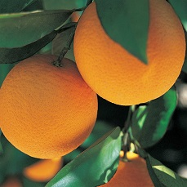“Europe’s not in a good place. We’re loading much more for the UK than for Europe at the moment, about 15 to 20 containers of lemons, Novas and oranges for the UK a week, and it’s going to get more with the late mandarins."
"It’s never been the case before, and if it continues, it’ll be the first season ever that we send more to the UK than to Europe. Usually we send about 20% to the UK and 30% to the EU. Of course, Valencias still have to start and we easily send 50 containers a week so that could change the whole picture.”
The company has UK retail programmes which anchor their business in that part of the world and give them breathing space in a year like this.
“Europe’s very negative about navels. And just to give you an idea: Morocco has just started picking their late navels (Barnfields, very nice fruit, from what I’ve seen), waiting until after Eid, while we have also started picking. Spain will probably have fruit until week 30, staying in the market at least two weeks longer.”
“In northern Europe the demand is slightly increasing, but the interest is far below other years.”
In this could lie an opportunity, Snyman feels, provided that navel exporters exercise patience now and wait for volumes to clear and a vacuum to take shape.
Late mandarins looking good
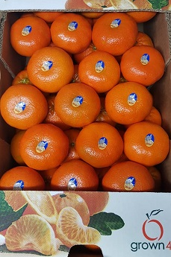Grown4U is looking forward to the start of the late mandarin season, kicking off with Valley Gold this week.
In week 27, Nadorcotts and Tangos will start. “Tangos are definitely earlier than Nadorcotts, you can see it when you compare two orchards growing side by side. Tangos are a week or 10 days earlier, and putting the orchards under netting makes them even earlier.” “The Tangos look a lot better than last year on sizing.”
Problems at the port
Snyman mentions that they have been affected by problems like wind bringing port operations to a halt and backlogs at Port Elizabeth Harbour, some of which are due to the problems at Durban Harbour, causing them to miss shipping dates and therefore programme delivery dates.
For more information:
Snyman Kritzinger
Grown4U
Tel: +27(42) 230 0760
Email: info@grown4u.co.za
https://www.grown4u.co.za/

Publication date: 6/13/2019
Author: Carolize Jansen
© FreshPlaza.com

