Fresh PLAZA – 6TH August 2018

Constitution already allows for land expropriation without compensation when “in the public interest“, ANC reiterates

South Africa: Land reform announcement disquiets but delivers nothing new
Last Tuesday evening President Cyril Ramaphosa, in his capacity as ANC president, devoted a short television announcement to the vexatious matter of land reform and, specifically, land expropriation without compensation. Despite a nervous reception in some quarters, there was nothing new to his message: in March the party released its formal position on land reform in which they stated that the expropriation of land without compensation “should” be among the key mechanisms available to them.

His statement made clear that the ANC believes land expropriation without compensation is already permitted under the current constitution, with the caveat that it happens in the public interest.

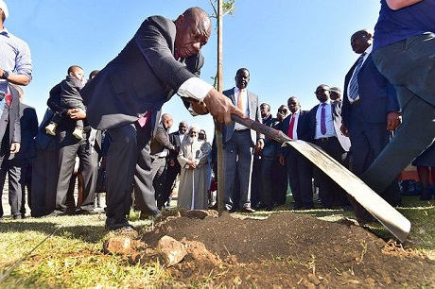
President Cyril Ramaphosa planting a tree in the Eastern Cape community of Mvezo for Mandela Day this year (photo: GCIS)

“A proper reading of the constitution’s property clause enables the state to effect expropriation of land with just and equitable compensation and also expropriation without compensation in the public interest,” he stated, continuing that the party would submit a proposed amendment to the parliament’s constitutional review committee “to set out more clearly the conditions under which expropriation without compensation can be effected”.

What is still less clear, is what land would fall under the ANC’s target of “vacant, unused and under-utilised state land, land held for speculation and hopelessly indebted land” but once again during this television address Pres Ramaphosa had paid homage to the matters of sustained agriculture production and food security.

Two days later the Minister for Agriculture, Senzeni Zokwana, reiterated the view that food production should never be adversely touched by land reform. He mentioned that a grain seed company manager had told him that farmers were re-considering seed purchases for the coming season. “The call is on farmers, those who are producing food, not to panic but to make sure that they participate in processes,” the minister said.

Meanwhile, thousands of South Africans, including organised agriculture and the South African fruit industry, have been taking part in public hearings across the country, with the aim of informing parliament’s constitutional review committee which is set to report back in September on whether the constitution should be amended.

A Mpumalanga citrus farmer doesn’t think there’s reason for concern regarding continuity of supply because of the ANC’s repeated reassurances that agrarian reform would occur within the constraints of food security and the economy, but he does note that the Economic Freedom Fighters (EFF) are creating an atmosphere of uncertainty in rural areas of Mpumalanga and, particularly, Limpopo (the home province of EFF commander-in-chief Julius Malema) and that in this environment, mechanisation looks increasingly attractive to farmers and that uncertainty deters investment.

He refers to the strike in the citrus industry of the Sundays River Valley (Eastern Cape) at the beginning of June as an example of the influence of pre-election politics on the agricultural sector.

“Narrative on land reform consistently runs away from ANC”
Political pundits uniformly see the ANC address as an attempt to neutralise the EFF who have been dominating the debate on land expropriation, taking advantage of disarray within the ANC while it was in the process of lifting former president Jacob Zuma out of the cushions.

“The ANC is a mess,” writes author Sello Lediga and that within these divisions, Ramaphosa has seized the moment like “a buffalo” to show that he is the undisputed leader of the post-Zuma ANC and of the country in general.

He further states: “Left-wing romanticists dreaming of a land grab in South Africa similar to that of Zimbabwe will be defeated through a controlled process of meaningful land reform.”

Not all are as sanguine. Respected journalist Mondli Makhanya said this weekend that South Africa would “rue” the day if it chose the route of Zimbabwe.

“It is clear that the narrative has consistently been running away from them [the ANC] and every time in an attempt to regain control, they seem to cause more confusion and anxiety with investors as well as current property owners,” notes political commentator Melanie Verwoerd. “It [has] become clear that the EFF has succeeded in creating a false public narrative around the necessity for the constitutional amendment. It has become generally accepted that any argument against the amendment of the Constitution implies a resistance to land reform.”

President Ramaphosa’s announcement was perhaps primarily an attempt to re-take charge of the tone of public discourse, or “pull out the rug from under the EFF in an election year” as an economic analyst tells FreshPlaza, but it was always going to create yet another frisson of uncertainty through a country that feels on edge.

“All we can do is wait and see what the Full Monty looks like,” concludes a fruit famer.

Publication date: 8/6/2018
Author: Carolize Jansen
Copyright: www.freshplaza.com

