FRESH PLAZA ARTICLE:

341 dead so far this year

People gather to show solidarity with South African farmers
Today people are being urged to wear black in a show of solidarity with South Africa's farmers. Over the past five days, 11 farm attacks have taken place in South Africa, which led to the death of four people. Since 1 January 2017 at least 341 farm attacks have already been carried out, during which 70 people have been murdered.
Photo courtesy of Andre Potgieter
Justin Chadwick CEO of the Citrus Grower's Association in South Africa, himself the son of a farmer wrote in his weekly column, "These are mere statistics, hiding the impact that these senseless acts have on families and communities. Farmers are the lifeblood of the nation; without farmers we would have no food, without farmers we would not exist. Think about it – if farmers were not ensuring that there is food available, each and every one of us urban dwellers would have to produce our own. Apart from the impracticality of doing this – it would also mean that we could focus less of our time on our jobs. The entire economy is built on the fact that farmers produce our food. We cannot allow these senseless attacks to continue.
"Wherever you are in the world, wear black to show that you care about South African farmers. In addition, post and tweet pictures and comments to show you care. We are calling on the government to address farm attacks in South Africa as a priority, to work with organised agriculture, commodity groups, farming communities and individual farmers in a bid to stop this atrocity."
Meanwhile, farming group Agri SA has also demanded that violence against farm communities must stop.
“It has long been time for the public and the government to take note of the brutality of farm attacks, as well as the onslaught aimed at members of the farming community. For this reason, Agri SA supports the awareness campaign that kicks off on Monday, 30 October 2017, with South Africans expressing their support by wearing black,” said Agri SA President Dan Kriek to The Messenger, a Western Cape newspaper.
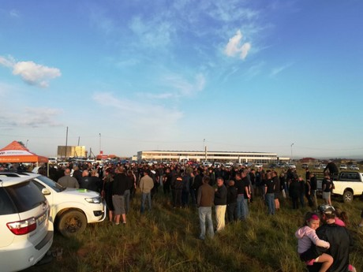
People already gathering at events across South Africa Photo - Ernst Roets‏ - Twitter
“Farmers are vulnerable, and it is therefore important to be prepared at household level and, through community involvement, to curb this violent onslaught. One of the pillars for community participation in rural safety is the implementation of the Rural Safety Strategy. Becoming more proactive means that the individual and the community must be ready and prepared for any event and this is only possible when farmers and farm workers are involved in the structures of organised agriculture.”
Kriek concluded: “I am fully aware of the emotional stress experienced within farming communities and that Agri SA and its provincial organisations will continue to seek solutions to stop the violent onslaught waged against our farming communities.
“South Africa cannot afford any further violence against farming communities. Farm attacks and the brutality thereof must be strongly condemned by all South Africans.
“We think of the thousands of fellow South Africans who have lost their lives during the past year as a result of violent crime, 52 murders a day! Many farmers and farm workers are among those who have paid the highest price,”
Publication date: 10/30/2017
Author: Nichola Watson
Copyright: www.freshplaza.com

