FRESH PLAZA – 1st November 2017

Organisation believes new financing model with subsidised interest rates will reignite land reform process

Land audit: 46.5% of South Africa's high-potential agric land in hands of emerging farmers
AgriSA today released its land audit, the first of its kind to calculate the amount of land in the hands of PDIs (previously disadvantaged individuals, meaning South Africans who are not white).

“We decided: let’s put a peg in the ground and get a factual basis for the land debate,” explains Omri van Zyl, AgriSA executive director. “Agriculture is the basis to fire up the economy. It is two to three times more efficient to reduce poverty than any other sector of the economy.”

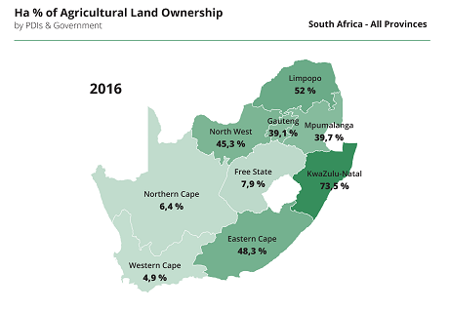
This map shows that the highest rates of black land ownership coincides with the areas with highest agricultural potential, in the east of the country (PDIs = Previously Disadvantaged Individuals)

The absence of a factual basis for discussions around land ownership was termed “the elephant in the room” by Dan Kriek, newly appointed president of AgriSA. “We want to open up constructive debate around land reform, in order for the process to be done constitutionally and commercially.”

Because there is a significant east-west difference to the potential of agricultural land in South Africa – the west is arid, the east has much higher rainfall – it was decided to base the audit (initiated by Agri Development Solutions and Landbouweekblad, in conjunction with AgriSA) not on acreage alone, but also on the value of land as well as its potential.

Through looking at land transactions – involving hundreds of thousands of transactions from 1994 up until the present – it was found that currently 26.7% of agricultural land is in the hands of government and previously disadvantaged individuals (PDIs), representing 25 million hectares. To put it into further context, using the potential and the economic value of the land, this amounts to 29.1% of total agricultural land value in South Africa and 46.5% of the total potential of South Africa’s agricultural land.

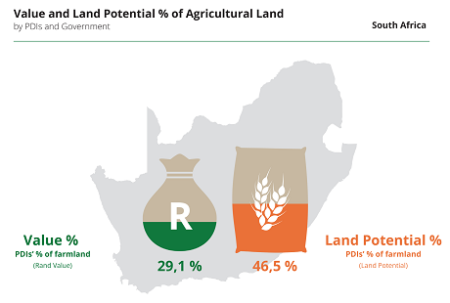
PDI: Previously Disadvantaged Individual

The reason that land now held by black emerging farmers represents so much of South Africa’s agronomically high potential land, is because of high black land ownership in eastern provinces like KwaZulu-Natal, Eastern Cape as well as Limpopo.

Furthermore, the audit found that twice as many black emerging farmers had obtained their land through private purchases (4.3 million ha) than beneficiaries of the government’s land reform programme (2.2 million ha), reinforcing their view that the private sector can speed up the efficiency of land transfer processes.

“The most successful black farmers are those that have bought their own land,” says Christo van der Rheede, deputy executive director. “For instance Coloured fruit farmers in the Western Cape. A big part of their success is due to their affiliation with Hortgro.”

However, emerging farmers have a universal concern: lack of secure tenure and lack of access to capital for farming operations and growth. A major stumbling block is that farmers who are based in traditionally communal (‘tribal’) lands where private land ownership is forbidden, are therefore disqualified from accessing commercial credit.

“We propose a new strategy for sustainable agrarian reform. A lack of access to capital is the single biggest inhibitor to emerging farmers at the moment,” Omri van Zyl says. “We suggest subsidisation of interest rates from government. Through commercial funding mechanisms we can leverage more from government. We believe we can transfer property at double or quadruple the rate that it is done currently.”

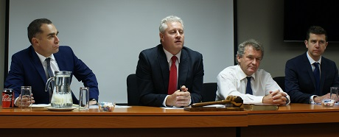
Omri van Zyl, executive director of AgriSA, Dan Kriek, AgriSA's president, Ernest Pringle, chair of the Agricultural Development Committee and Requier Wait, head of economics and trade at AgriSA

They emphasise that their focus on high-potential land is reiterated in the National Development Plan. They’re also adamant that emerging farmers must be integrated into the value chain and commodity organisations like Hortgro or the CGA.

Other priorities are the stimulation of underfunded irrigation schemes and to get the eastern part of South Africa as productive as is possible.

“We’re reigniting the constitutional dream while rectifying the injustices of the past,” concludes Dan Kriek, president of AgriSA.

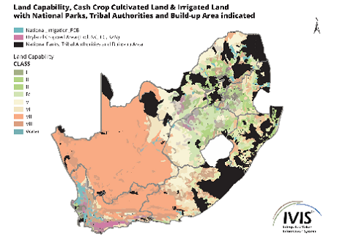
Map showing the potential of land. Black areas represent national parks, communal lands and built-up areas. High-potential land is denoted by shades of green. Purple areas are dryland cropped areas (excluding the Northern and Eastern Cape and KwaZulu-Natal).

Publication date: 11/1/2017
Author: Carolize Jansen
Copyright: www.freshplaza.com

