FRESH PLAZA: 10th September 2018:

Maradadi Farm, Letsitele Valley: a successful community-private partnership

“If you want your stomach to be full, go to agriculture”
In the picturesque Letsitele Valley lies Maradadi Farm, a successful citrus farm. What makes this farm unique is that its production manager is a woman, and a black woman at that.

Next month it will be a year since Kate Hlongo was appointed to this position. Although Kate didn’t start out with an interest in agriculture, she has worked herself up through the ranks to her current position. Starting as an entry level general farm worker, her serious demeanour is a clue to what has made her successful in a farming enterprise where attention to detail is of paramount importance. Only Nadorcotts are grown on the farm where 3,000 tonnes were harvested this year, the majority marketed as ClemenGold.

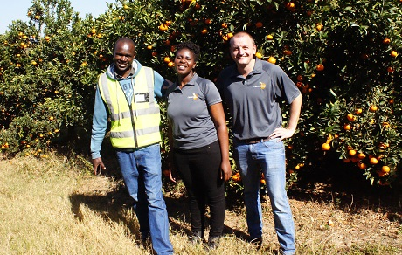
Andrew Mongwe (senior supervisor), Kate Hlongo (production manager) and Diederik Fourie (area manager) on Maradadi Farm

The farm was returned to the BaThlabine community in 2001 after a successful land claim. Indigo Fruit Farming, part of the ANB Group, approached the community five years ago to optimise the underused piece of land, recognising the area’s particular value for soft citrus. The farm is now on a straight lease from the community, while giving community members preference in employment and learnerships that are transferring plant production skills.

Sixty percent of workers on the farm are women. When harvesting, bins are moved closer to pickers, placed on ground level, to reduce the distances they have to walk.

Andrew Mongwe, senior supervisor on the farm, is one of the beneficiaries who started his plant production studies in 2011 under the guidance of Indigo Fruit Farming. He inherited his claim from his grandmother. He was born and raised in neighbouring Lephane Village, where he’d studied agriculture at school, which worked in his favour when Indigo Fruit Farming was advertising learnerships.

“I used to tell people: when you see the president addressing people, it’s because his stomach is full and it’s because of agriculture. That is where I got motivated. If you want your stomach to be full, you must go to agriculture,” he says.

“I never imagined I’d work on this farm, I used to look at it before when it had some citrus and some pawpaw and some mangoes. Indigo planted a seed, which is me, and I think I’m getting better and better.”

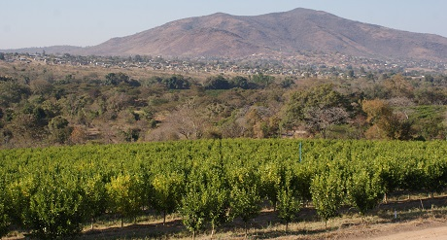

Model for successful community-private enterprise partnerships
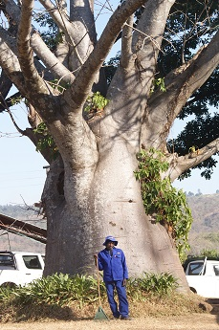
Indigo Fruit Farming will manage the farm for twenty years (fifteen still to go), at which time the lease is up, and ideally the beneficiaries of the project and recipients of the skills transfer courses will then be in a position to take over the running of the farm, but at the moment both parties benefit from the arrangement.

The opportunity to farm with Nadorcotts is one a rural community could never have afforded on its own but CitroGold, the ANB subsidiary responsible for the management of plant breeder's rights, afforded this farm their share of plantings. It has been estimated that soft citrus production costs up to 20% more per hectare than hard citrus, but it’s worth it, because a 1% or 2% packout improvement translates to a big increase in income because of the high value of the product.

Picture right: one of several baobab trees on the farm.

“As a model of how to manage underperforming land claims farms, this is one that we think will be increasingly followed in future,” says Diederik Fourie, area manager of Indigo Fruit Farming. “You have to enter into these agreements with the right mindset. It’s incredibly important to keep the channels of communication open.”

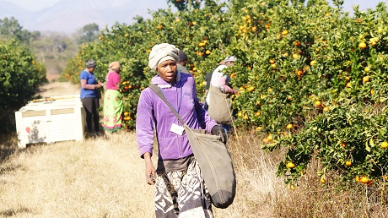
Women picking fruit on Maradadi Farm, late July
Publication date: 9/10/2018
Author: Carolize Jansen
Copyright: www.freshplaza.com

